SQL HANDS-ON DAY3
ANSWER

CREATE TABLES

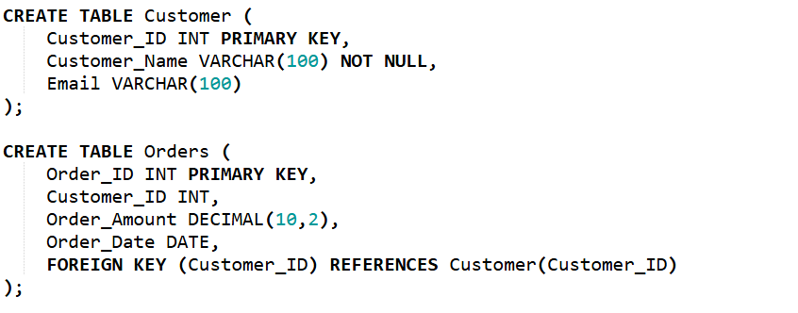
INSERT SAMPLE DATA
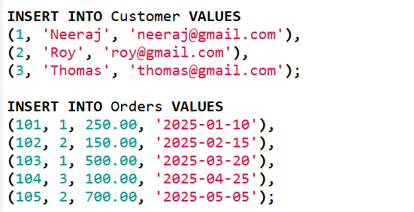

1. Create an index on Customer_ID in Orders table
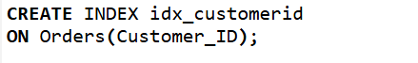

2. Query to test performance for searching specific Customer_ID

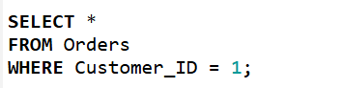
Output:
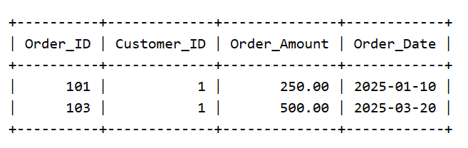
3. Identify column to be indexed in frequently joined table
-->Customer_ID should be indexed because
--> it is frequently used in JOIN conditions.

4. Create composite index on (Customer_ID, Order_Amount)
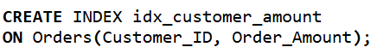

5. Drop existing index

6. Create table partitioned by range on Order_Date
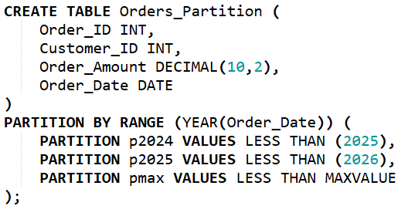

7. Insert data and verify partition placement
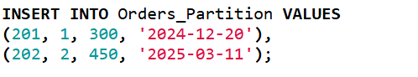
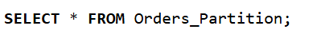
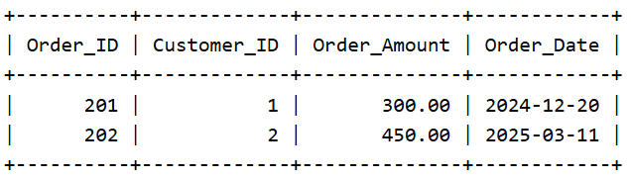

8. Query data from specific partition
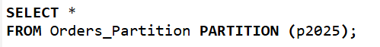
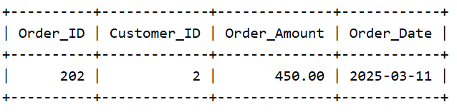

9. Create hash partitioned table using Customer_ID
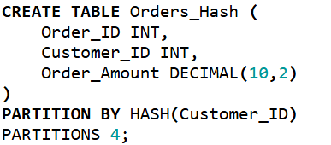

10. Demonstrate partition pruning with a query. Constraints
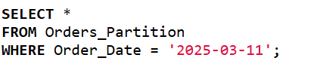
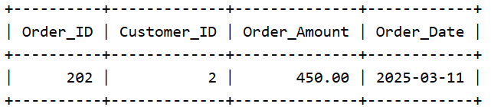

11. Create Customer table with PRIMARY KEY and NOT NULL constraint.
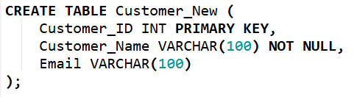

12. Add a FOREIGN KEY constraint linking Orders and Customer.
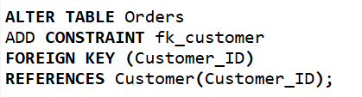

13. Add a UNIQUE constraint on Email column.
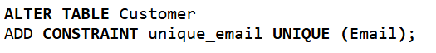

14. Add a CHECK constraint ensuring Order_Amount > 0.
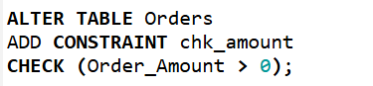

15. Drop a constraint from a table. CTE
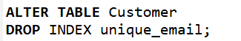

16. Write a CTE to filter orders greater than 200.
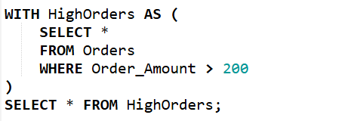
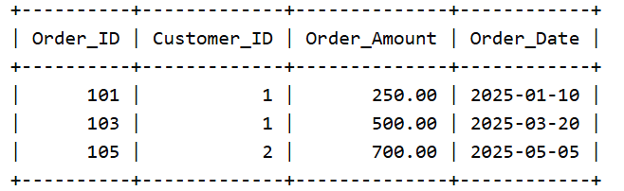

17. Use CTE to compute total order amount per customer.
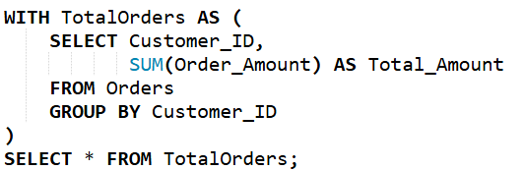
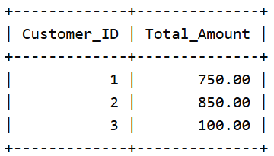
18. Use multiple CTEs for aggregation and filtering.
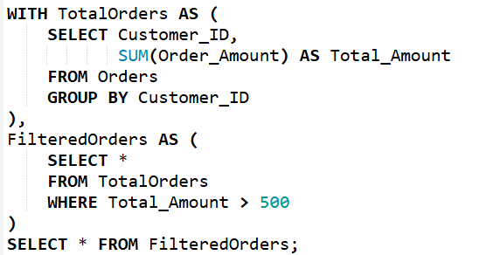
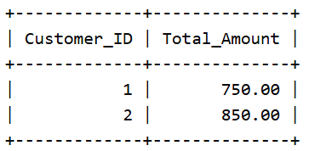

19. Write a recursive CTE to generate numbers 1 to 10.
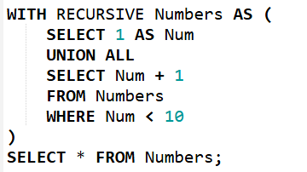
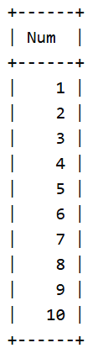

20. Use CTE in a JOIN query. Temporary Tables
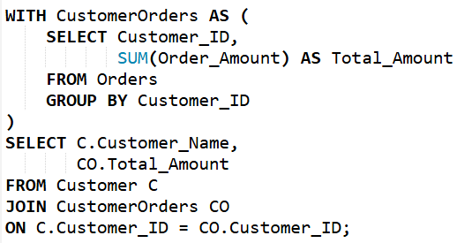
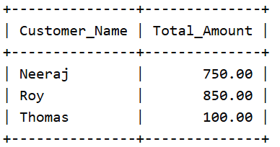

21. Create a temporary table for high-value orders.
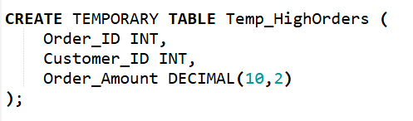

22. Insert filtered data into the temp table.
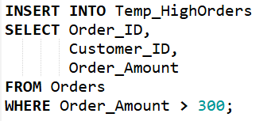

23. Query the temp table multiple times.
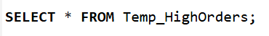
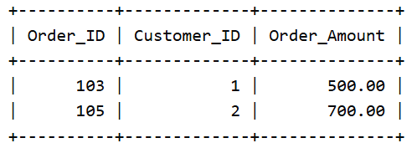

24. Compare results of CTE vs temp table.
--> CTE exists only during query execution.
-->Temporary table exists until session ends.

25. Drop the temporary table.

